Create a simple counter application using React Hooks. The app should display a number and provide buttons to increase, decrease, and reset the count.

App.js

import React, { useState } from 'react';
import './App.css';

function App() {

// State variable to store counter value (initial value = 0)
const [count, setCount] = useState(0);

// Function to increase counter by 1
const increase = () => {
setCount(count + 1);
};

// Function to decrease counter by 1
const decrease = () => {
setCount(count - 1);
};

// Function to reset counter to 0
const reset = () => {
setCount(0);
};

// JSX returned by component
return (
<div style={{ textAlign: "center" }}>

{/* App title */}
<h2>Counter App - 6709</h2>

{/* Display current counter value */}
<h1>{count}</h1>

{/* Button to decrease counter */}
<button style={styles.spacing} onClick={decrease}>
Decrease (-1)
</button>

{/* Button to reset counter */}
<button style={styles.spacing} onClick={reset}>
Reset (0)
</button>

{/* Button to increase counter */}
<button style={styles.spacing} onClick={increase}>
Increase (1)
</button>

</div>
);
}

// Style object for button spacing
const styles = {
spacing: {
margin: "10px", // Space outside button
padding: "10px", // Space inside button
}
};

export default App;

Output: Counter app
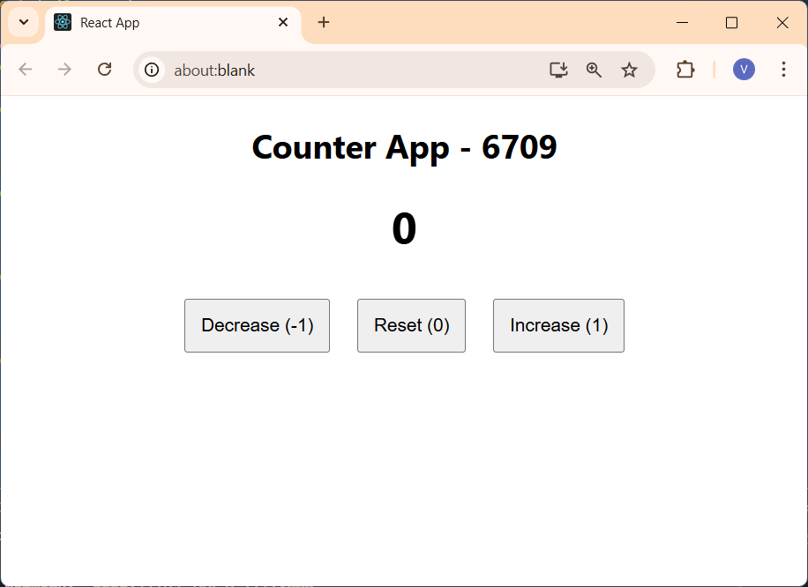

Increasing count by 6
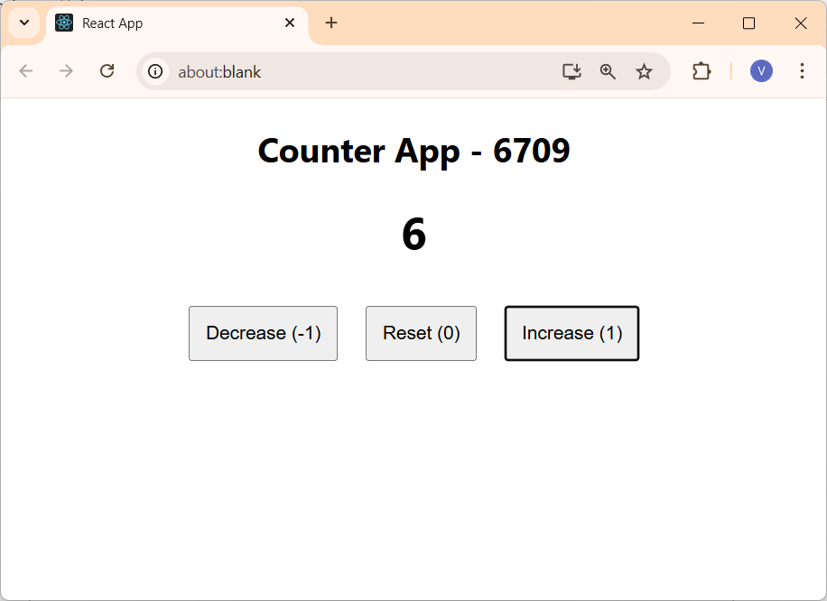

Decreasing count by 2
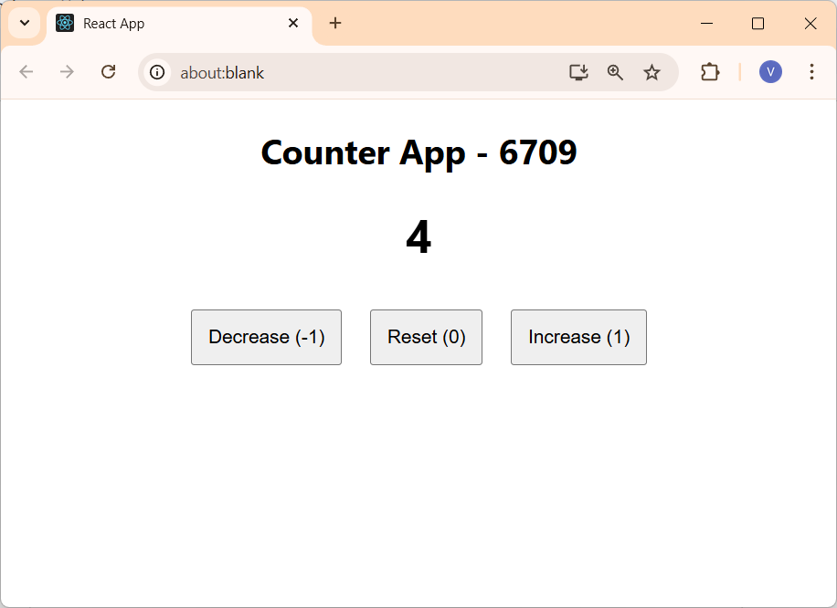

Using reset button
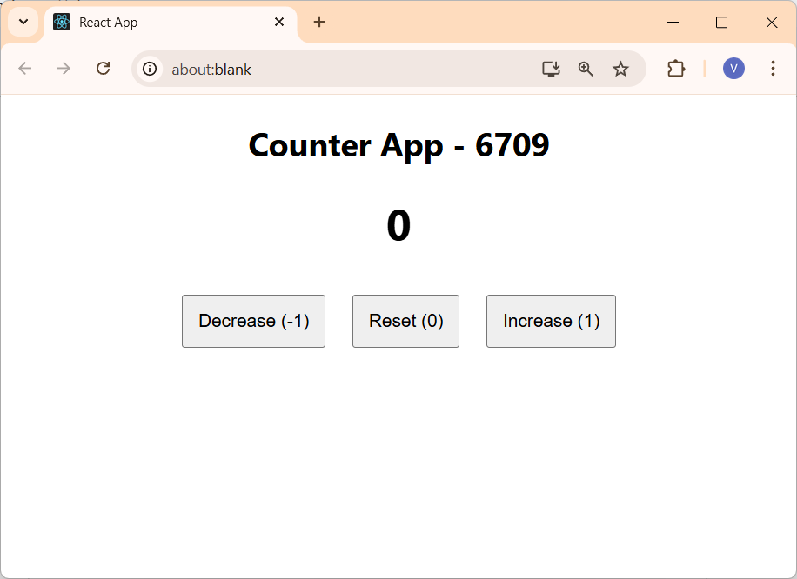

Build a Todo application where users can delete and add new tasks.

App.js

import { useState } from 'react';

// Main App component
function App() {

// State to store list of tasks (initially empty)
const [tasks, setTasks] = useState([]);

// State to store input value from textbox
const [input, setInput] = useState('');

// JSX returned by the component
return (
<div>

{/* App title */}
<h2>Todo App - 6709</h2>

{/* Input box to enter new task */}
<input
value={input} // Bind input value to state
onChange={(e) => // Trigger when user types
setInput(e.target.value) // Update input state
}
placeholder="Enter a new task" // Placeholder text
/>

{/* Button to add task */}
<button
onClick={() => {
if (input) { // Check input is not empty
setTasks([...tasks, input]); // Add new task to task list
setInput(''); // Clear input box
}
}}
>
Add
</button>

{/* Display all tasks */}
<div>
{tasks.map((task, i) => ( // Loop through task array
<div key={i}> {/* Unique key for each task */}
{task} {/* Display task text */}
{/* Delete button */}
<button
onClick={() =>
setTasks(
tasks.filter((_, idx) => idx !== i)
) // Remove selected task
}
>
Delete
</button>
</div>
))}
</div>

</div>
);
}

export default App;

Output: To Do App

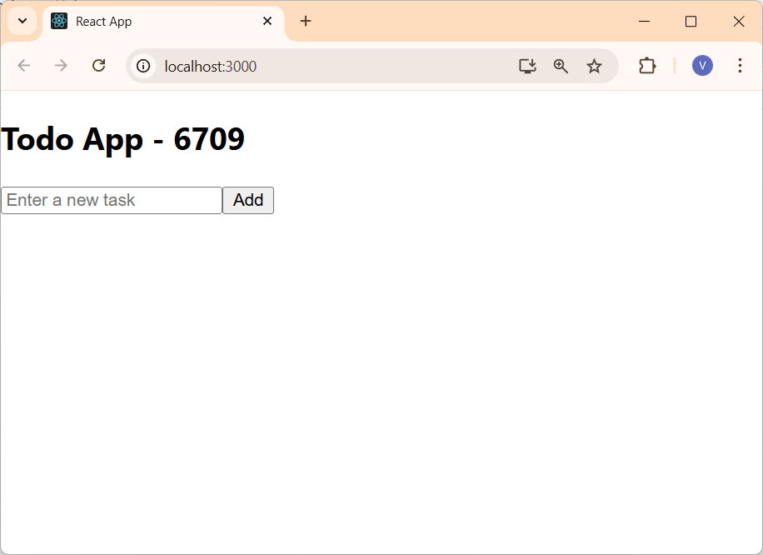

Adding few task
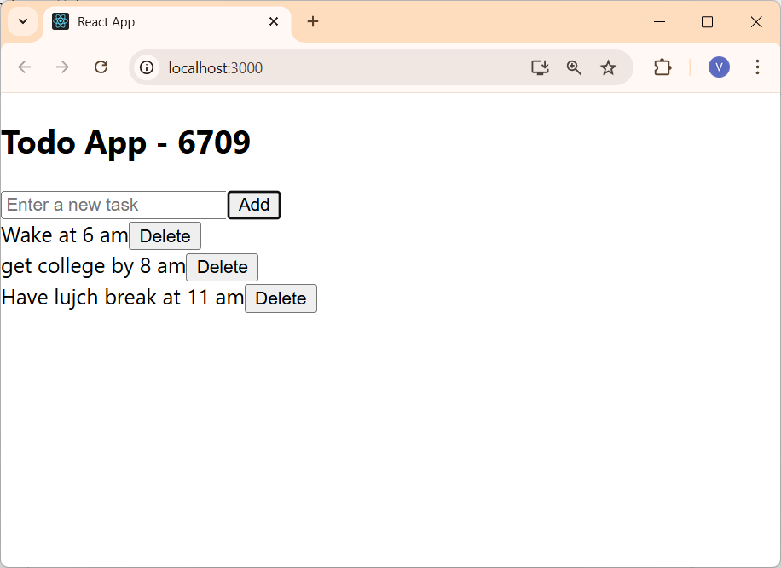

Deleting 1st and 3rd task from list
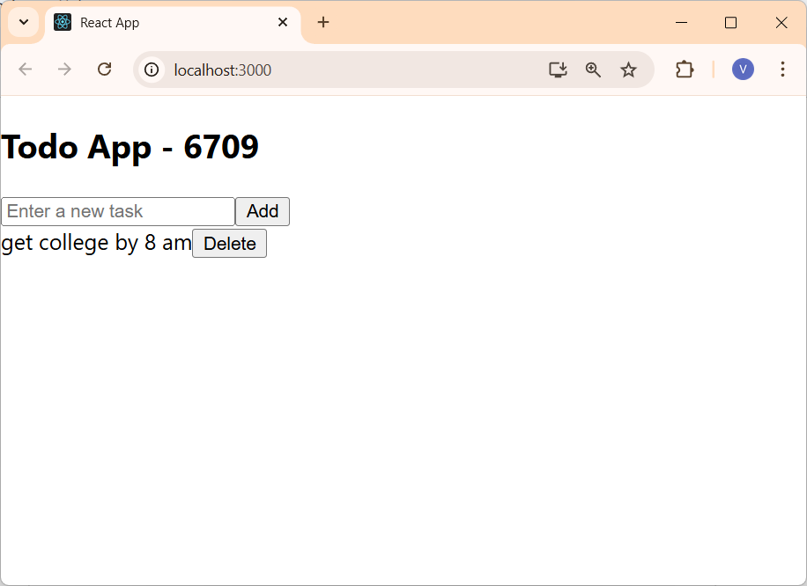

Develop a React application using the Context API where a counter value is shared between components. Use the useEffect hook to:
  - Log when components are mounted and unmounted
  - Log changes whenever the shared state updates
  - Demonstrate the working of the application with a button to update the counter

CounterContext.js

import React, { createContext, useEffect, useState } from "react";

/*
* CounterContext - Creates a React Context for sharing counter state
* across multiple components without prop drilling.
* This context will hold the counter value and its setter function.
*/
export const CounterContext = createContext();

/*
* CounterProvider - A context provider component that manages the counter * state and makes it available to all child components.
*/
export function CounterProvider({ children }) {
// Initialize counter state with useState hook (starts at 0)
const [count, setCount] = useState(0);

// useEffect hook to log state changes for debugging purposes
// Runs whenever the 'count' value changes
useEffect(() => {
console.log("Counter updated:", count);
}, [count]);

// Provide the counter state and setter function to all child
// components via Context API's Provider component
return (
<CounterContext.Provider value={{ count, setCount }}>
{children}
</CounterContext.Provider>
);
}

CounterDisplay.js

import React, { useContext, useEffect } from "react";
import { CounterContext } from "./CounterContext";

/**
* CounterDisplay - Component that displays the current counter value
* Uses the CounterContext to access the counter state and render it.
*/
function CounterDisplay() {
// Extract count value from CounterContext using useContext hook
// This component will automatically re-render whenever count changes
const { count } = useContext(CounterContext);

// useEffect hook to log component lifecycle events
// Empty dependency array [] means this effect runs only once on mount
// The cleanup function runs when the component unmounts
useEffect(() => {
console.log("CounterDisplay mounted");

// Cleanup function: runs when component is removed from DOM
return () => {
console.log("CounterDisplay unmounted");
};
}, []);

// Render the current counter value
// Component automatically updates when count changes in context
return <h2>Counter Value: {count}</h2>;
}

export default CounterDisplay;

CounterButtons.js

import React, { useContext, useEffect } from "react";
import { CounterContext } from "./CounterContext";

/*
* CounterButtons - Component that provides UI controls to increment the
* counter Uses the CounterContext to access and update the counter state.
*/
function CounterButtons() {
// Extract setCount function from CounterContext using useContext hook
// This allows us to update the counter state without prop drilling
const { setCount } = useContext(CounterContext);

// useEffect hook to log component lifecycle events
// Empty dependency array [] means this effect runs only once on mount
// The cleanup function runs when the component unmounts
useEffect(() => {
console.log("CounterButtons mounted");

// Cleanup function: runs when component is removed from DOM
return () => {
console.log("CounterButtons unmounted");
};
}, []);

// Render button that increments counter on click
// Uses functional update form (prev => prev + 1) to ensure correct state updates
return (
<button onClick={() => setCount(prev => prev + 1)}>
Increase Counter
</button>
);
}

export default CounterButtons;

App.js

import React from "react";
import CounterButtons from "./CounterButtons";
import { CounterProvider } from "./CounterContext";
import CounterDisplay from "./CounterDisplay";

function App() {
return (
// CounterProvider wraps the app to provide counter context to all children Any component inside this provider can access the counter state
<CounterProvider>
<div style={{ textAlign: "center", marginTop: "50px" }}>
<h1>Context API Counter App</h1>
{/* CounterDisplay component shows the current counter value */}
<CounterDisplay />
{/* CounterButtons component provides button to increment counter */}
<CounterButtons />
</div>
</CounterProvider>
);
}

export default App;

index.js

import React from "react";
import ReactDOM from "react-dom/client";
import App from "./App";

// Get the root DOM element (typically <div id="root"></div> in index.html)
const root = ReactDOM.createRoot(document.getElementById("root"));

// Render the App component into the root container
// This starts the React application and renders all components
root.render(<App />);
Output

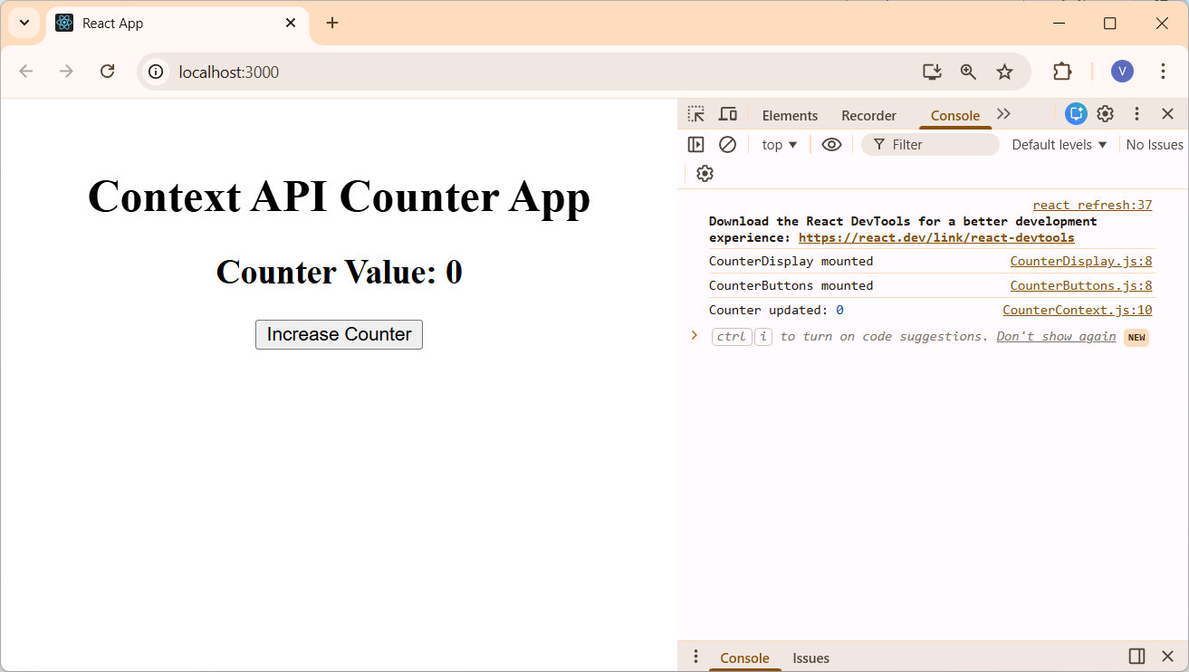

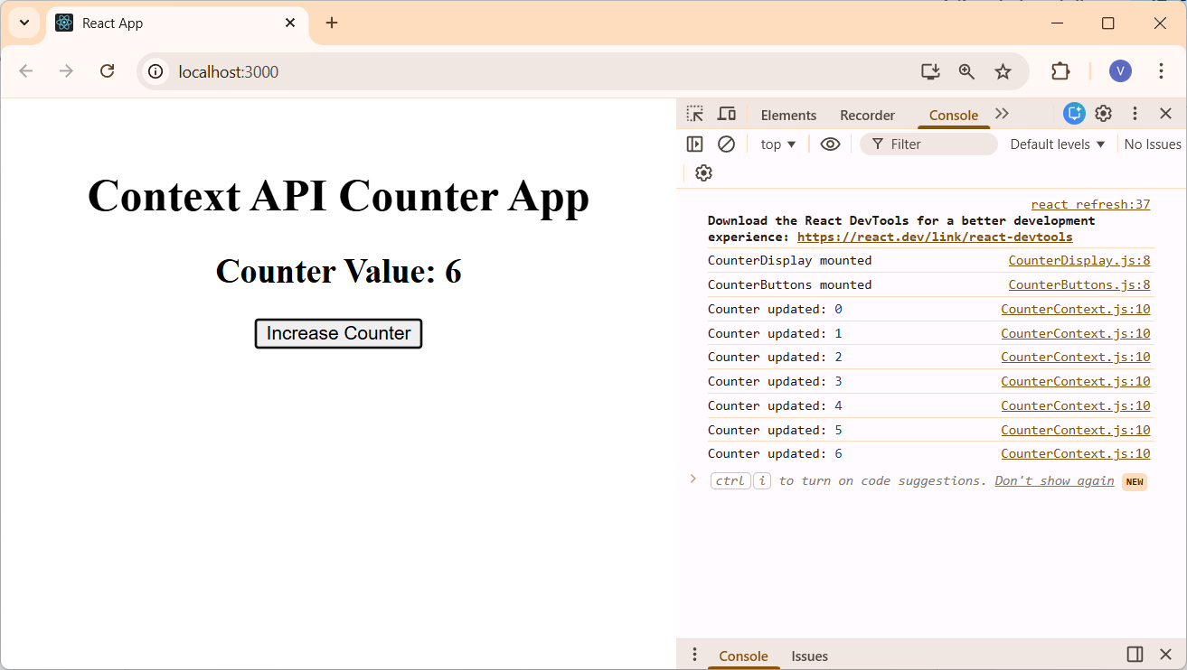

Create a React application using React Router that includes Home, Products, and Contact pages, with nested routing inside the Products page to display Car and Bike product lists using Link and Outlet.

Step 1: Create React Application
npx create-react-app react-router-demo
cd react-router-demo

Step 2: Install React Router
npm install react-router-dom

Step 3: Configure Router in index.js

import React from 'react';
import ReactDOM from 'react-dom/client';
import './index.css';
import App from './App';
import reportWebVitals from './reportWebVitals';
import { BrowserRouter } from 'react-router-dom';

const root = ReactDOM.createRoot(document.getElementById('root'));
root.render(
<React.StrictMode>
<BrowserRouter>
<App />
</BrowserRouter>
</React.StrictMode>
);

reportWebVitals();

Step 4: Define Routes in App.js.

import { Routes, Route, Link } from 'react-router-dom';
import Home from './components/Home';
import Products from './components/Products';
import Car from './components/Car';
import Bike from './components/Bike';
import Contact from './components/Contact';
import './App.css'

function App() {
return (
<div className='App'>
<nav>
<Link to="/">Home</Link> |{" "}
<Link to="/products">Products</Link> |{" "}
<Link to="/contact">Contact</Link>
</nav>

<Routes>
<Route path="/" element={<Home />} />
<Route path="/products" element={<Products />}>
<Route path="car" element={<Car />} />
<Route path="bike" element={<Bike />} />
</Route>
<Route path="/contact" element={<Contact />} />
</Routes>
</div>
);
}

export default App;

Step 5: Create Home Component

function Home() {
return <h2>Welcome to Home Page</h2>;
}

export default Home;

Step 6: Create Products Component

import { Link, Outlet } from 'react-router-dom';

function Products() {
return (
<div>
<h2>Products Page</h2>
<nav>
<Link to="car">Car</Link> |{" "}
<Link to="bike">Bike</Link>
</nav>

<Outlet />
</div>
);
}

export default Products;

Step 7: Create Car Component

function Car() {
return (
<ul>
<li>BMW</li>
<li>Audi</li>
<li>Tesla</li>
</ul>
);
}

export default Car;

Step 8: Create Bike Component.

function Bike() {
return (
<ul>
<li>Yamaha</li>
<li>Royal Enfield</li>
<li>KTM</li>
</ul>
);
}

export default Bike;

Step 9: Create Contact Component.

function Contact() {
return <h2>Contact Page</h2>;
}

export default Contact;

Step 10: Run the Application
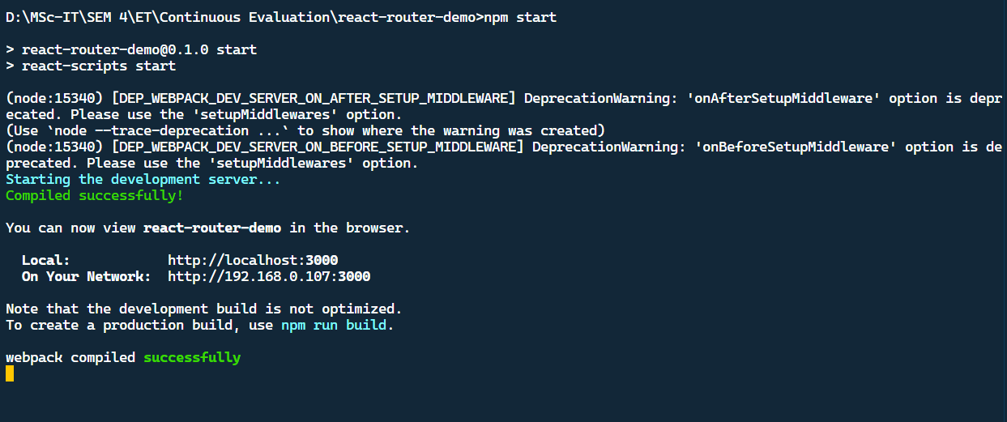

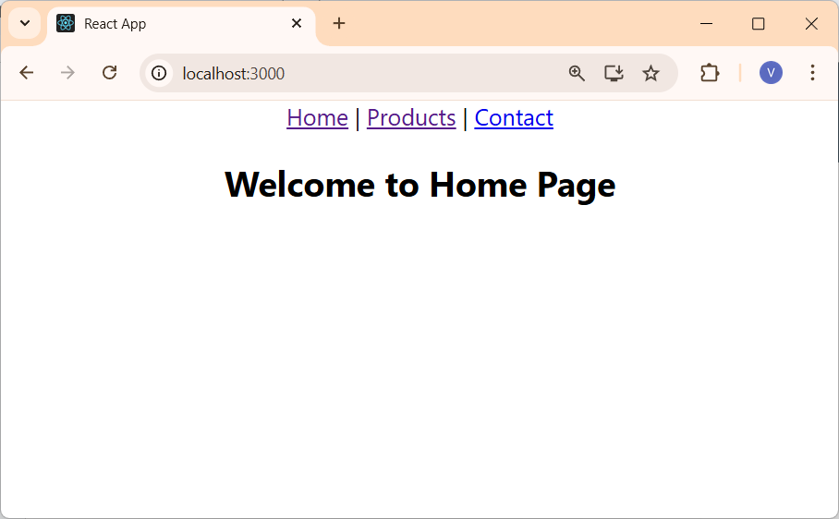

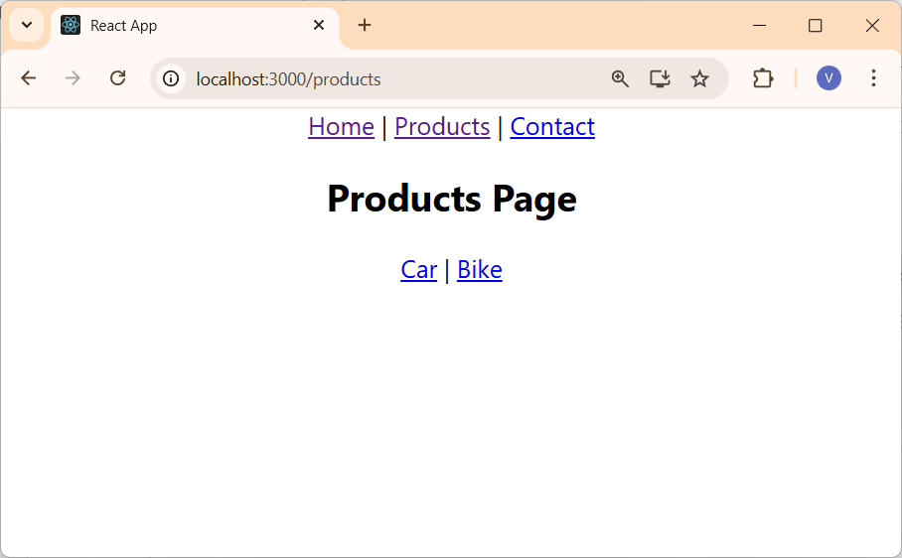

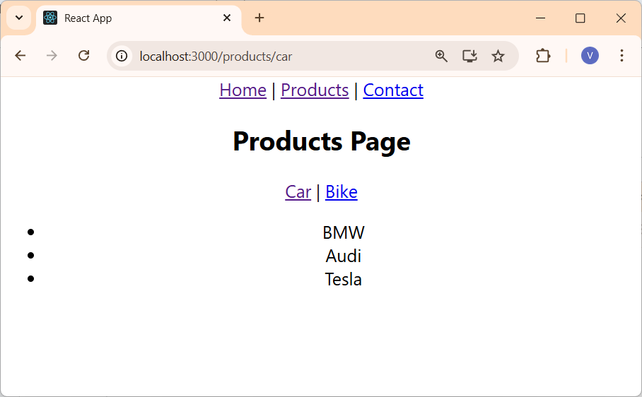

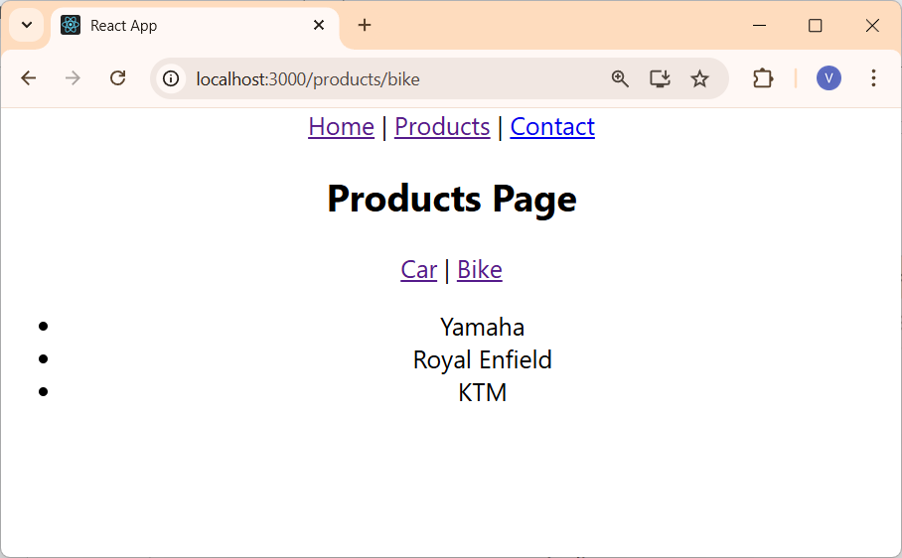

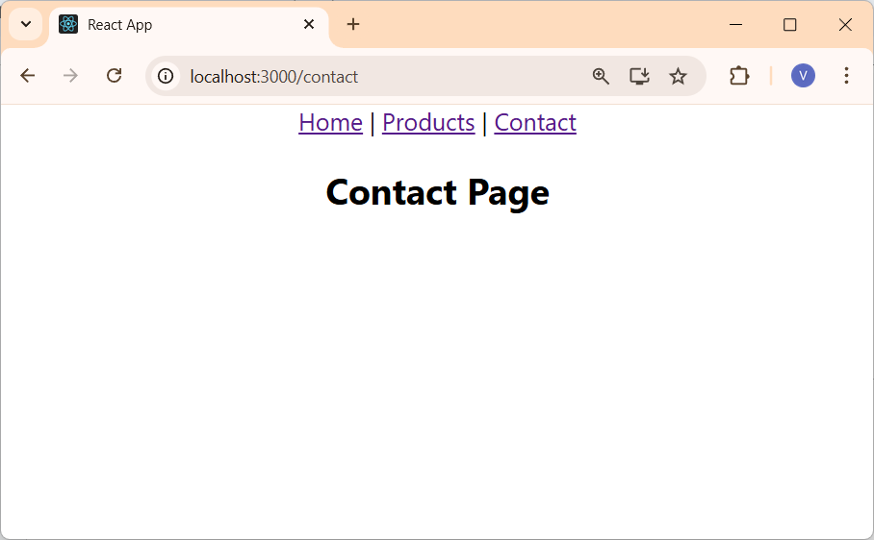

Build a React application using React Router that implements navigation between Home, About, and Contact pages with active link styling using NavLink and useParam Hook.

App.js

import {
BrowserRouter,
Routes,
Route,
NavLink,
Link,
useParams,
Outlet
} from "react-router-dom";

// Active NavLink styles
const navLinkStyles = ({ isActive }) => ({
color: isActive ? "#007bff" : "#333",
textDecoration: isActive ? "none" : "underline",
fontWeight: isActive ? "bold" : "normal",
padding: "5px 10px"
});

// Pages
function Home() {
return <h1>Home Page</h1>;
}

function About() {
return <h1>About Page</h1>;
}

function Contact() {
return <h1>Contact Page</h1>;
}

function Products() {
return (
<div>
<h1>Products Page</h1>
<nav style={{ marginBottom: '20px' }}>
<Link to="/products/car">Cars</Link> |{" "}
<Link to="/products/bike">Bikes</Link>
</nav>
<Outlet />
</div>
);
}

function CarProducts() {
return (
<div>
<h2>Cars</h2>
<ul>
<li>Audi</li>
<li>BMW</li>
<li>Volvo</li>
</ul>
</div>
);
}

function BikeProducts() {
return (
<div>
<h2>Bikes</h2>
<ul>
<li>Yamaha</li>
<li>Suzuki</li>
<li>Honda</li>
</ul>
</div>
);
}

// Nested customer info
function CustomerInfo() {
const { firstname } = useParams();
return <h2>Hello, {firstname}!</h2>;
}

// Customers page (combined)
function Customers() {
return (
<>
<h1>Customers</h1>

<nav style={{ marginBottom: "15px" }}>
<Link to="Komal">Komal</Link> |{" "}
<Link to="Sneha">Sneha</Link> |{" "}
<Link to="Hitali">Hitali</Link>
</nav>

{/* Nested route content renders here */}
<Outlet />
</>
);
}

function App() {
return (
<BrowserRouter>
<nav style={{ marginBottom: "20px" }}>
<NavLink to="/" style={navLinkStyles}>Home</NavLink> |{" "}
<NavLink to="/about" style={navLinkStyles}>About</NavLink> |{" "}
<NavLink to="/contact" style={navLinkStyles}>Contact</NavLink> |{" "}
<NavLink to="/products" style={navLinkStyles}>Products</NavLink> |{" "}
<NavLink to="/customers" style={navLinkStyles}>Customers</NavLink>
</nav>

<Routes>
<Route path="/" element={<Home />} />
<Route path="/about" element={<About />} />
<Route path="/contact" element={<Contact />} />
<Route path="/products" element={<Products />}>
<Route path="car" element={<CarProducts />} />
<Route path="bike" element={<BikeProducts />} />
</Route>
{/* Nested routing */}
<Route path="/customers" element={<Customers />}>
<Route path=":firstname" element={<CustomerInfo />} />
</Route>
</Routes>
</BrowserRouter>
);
}

export default App;

Output
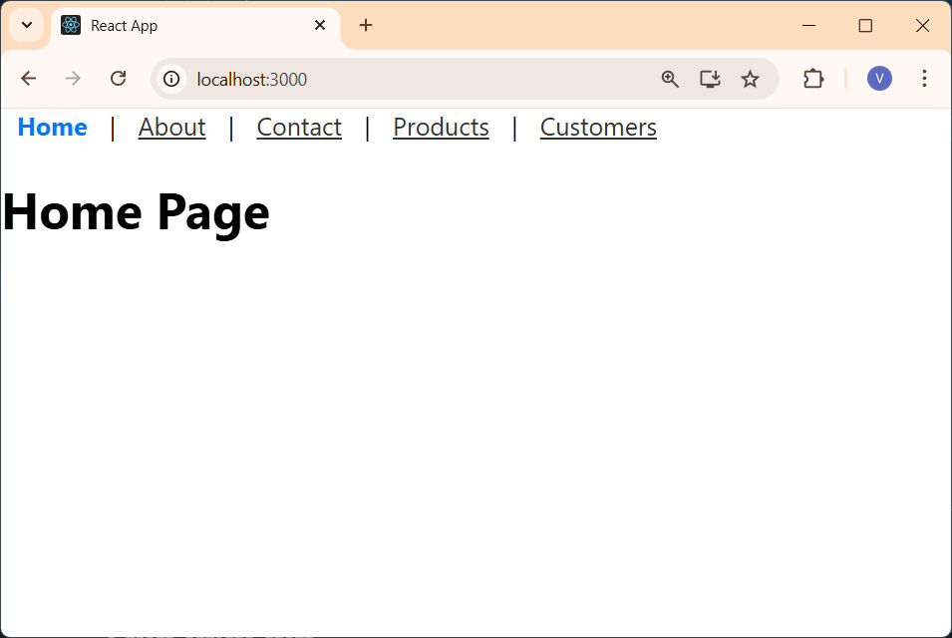

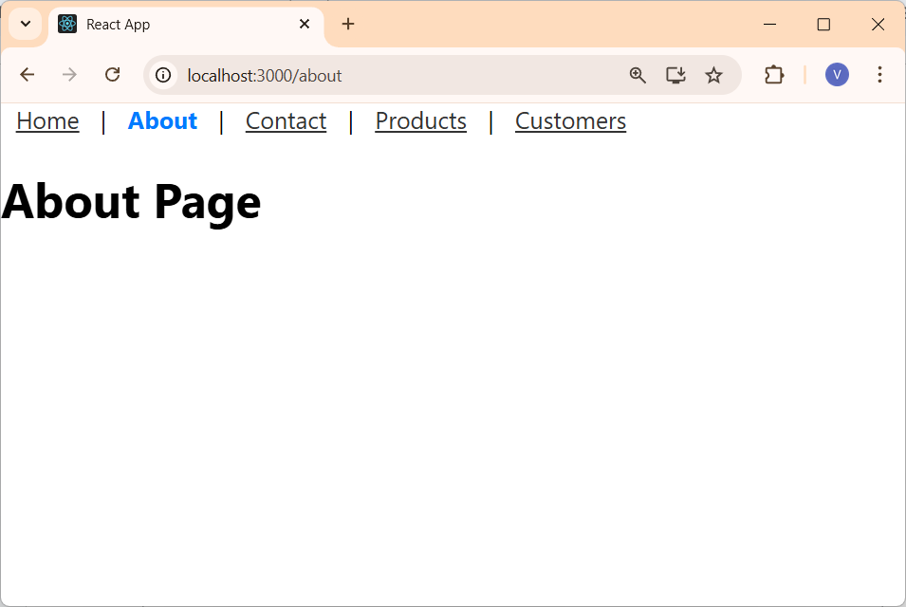

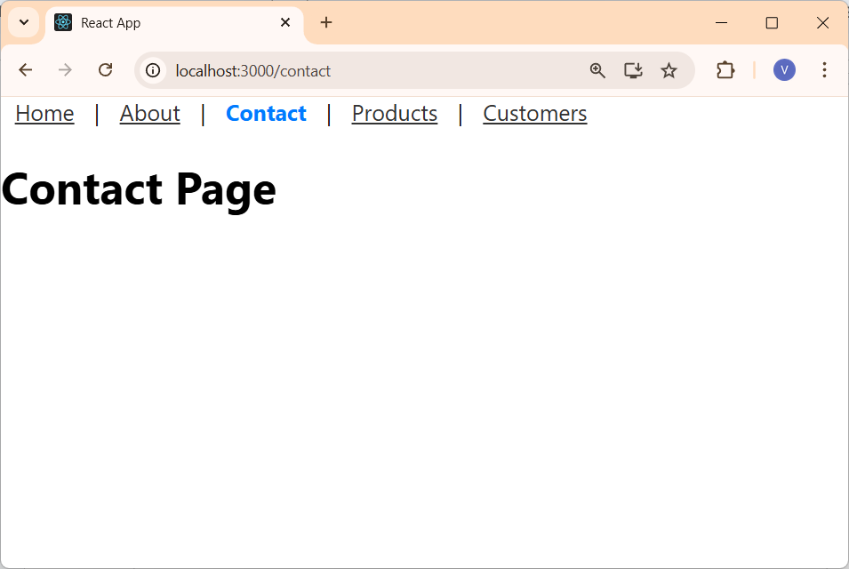

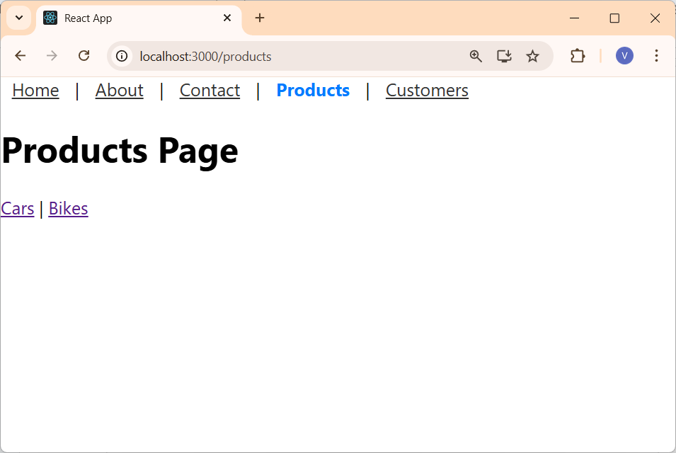

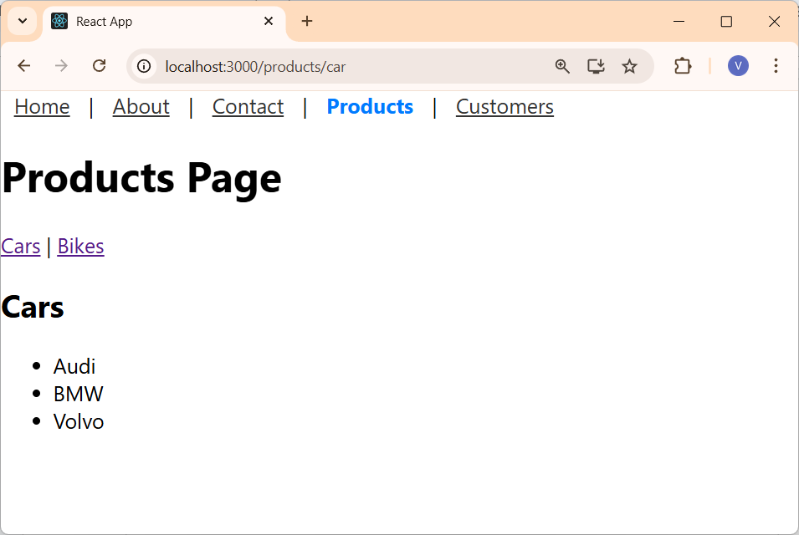

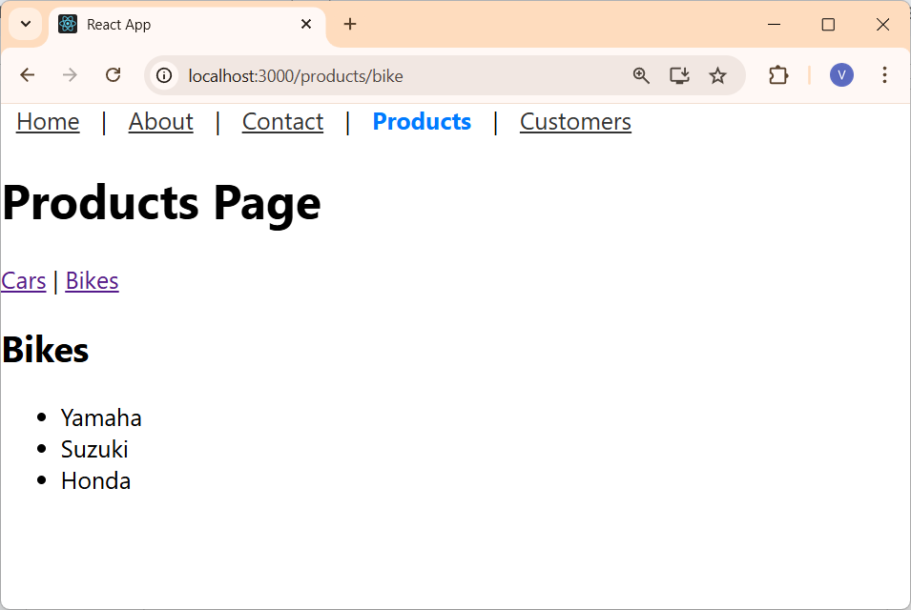

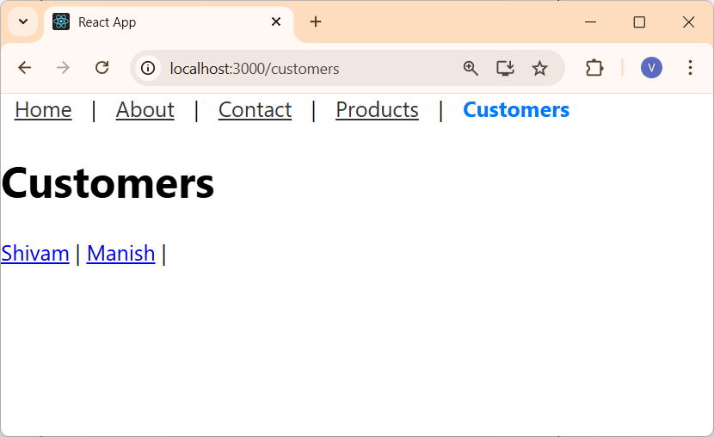

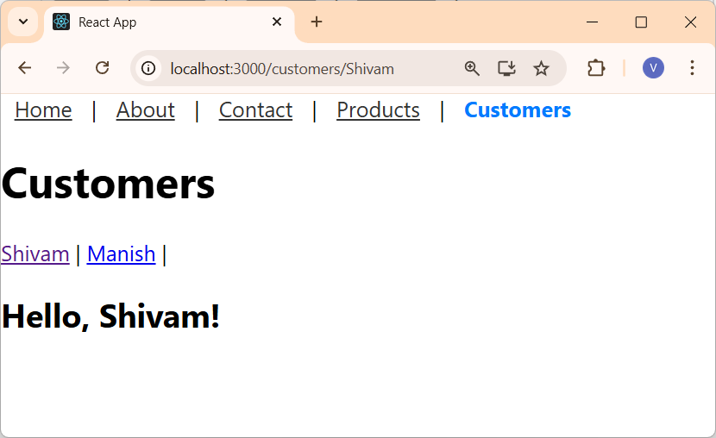

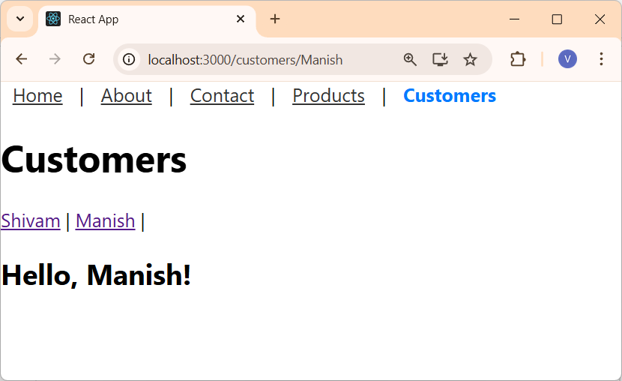

Create a Node.js application that allows a user to upload a .txt file containing user activity logs.The server should analyze the uploaded file and display statistics about different activity types. Also print the total number of files uploaded since the server started.

Sample.log file
[LOGIN] User logged in
[CLICK] Button clicked
[LOGOUT] User logged out
[LOGIN] User logged in
[ERROR] Invalid password
[CLICK] Link clicked

1. Create a folder for the project and write the following two commands
npm init -y
npm install express multer

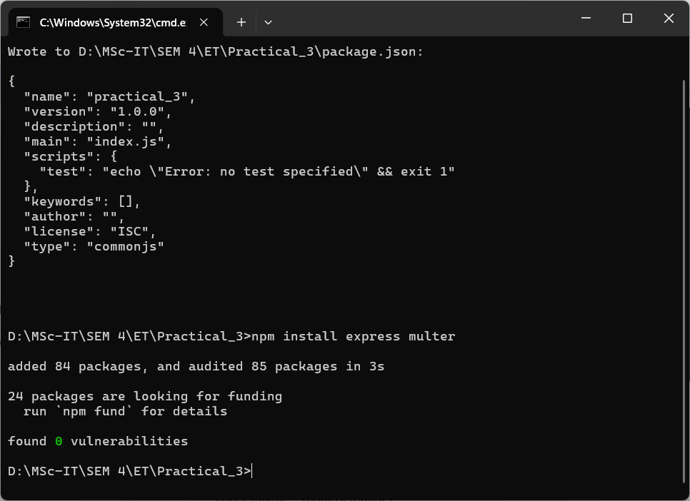

2. Create 2 folders name - public & uploads in root folder and add index.html file into public folder and server.js file into root folder

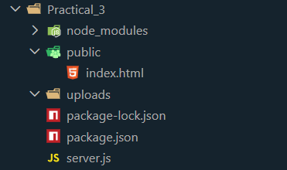

3. Write the below codes for each file

index.html

<!doctype html>
<html>
<head>
<title>6409 - Log Analyzer</title>
</head>
<body>
<h2>Upload a Log File</h2>

<form action="/upload" method="post" enctype="multipart/form-data">
<input type="file" name="logFile" accept=".log" required />
<button type="submit">Upload & Analyze</button>
</form>
</body>
</html>

server.js

const express = require("express");
const fs = require("fs");
const path = require("path");
const multer = require("multer");
const events = require("events");

// Initialize express app and event emitter
const app = express();
const eventEmitter = new events.EventEmitter();
const port = 3000;

// Create 'logAnalysis' directory if it doesn't exist
const logDir = path.join(__dirname, "logAnalysis");
if (!fs.existsSync(logDir)) {
fs.mkdirSync(logDir);
}

// Configure multer for file upload
const storage = multer.diskStorage({
destination: (req, file, cb) => {
cb(null, logDir);
},
filename: (req, file, cb) => {
const timestamp = Date.now();
cb(null, `log_${timestamp}.log`);
}
});

const upload = multer({ storage });

// Function to analyze log file
function analyzeLogFile(filePath) {
const logData = fs.readFileSync(filePath, "utf-8");

let infoCount = 0,
debugCount = 0,
errorCount = 0;

// Count log levels
infoCount = (logData.match(/\[INFO\]/g) || []).length;
debugCount = (logData.match(/\[DEBUG\]/g) || []).length;
errorCount = (logData.match(/\[ERROR\]/g) || []).length;

// Display results
console.log(`Total "INFO" events - ${infoCount}`);
console.log(`Total "DEBUG" events - ${debugCount}`);
console.log(`Total "ERROR" events - ${errorCount}`);

// Emit event to notify completion
eventEmitter.emit("logAnalysisCompleted");
}

// Event listener
eventEmitter.on("logAnalysisCompleted", () => {
console.log("Log analysis is completed!");
});

// Serve static index.html file
app.use(express.static(path.join(__dirname, "public")));

// File upload endpoint
app.post("/upload", upload.single("logFile"), (req, res) => {
const file = req.file;

// validate file type
if (file && path.extname(file.originalname) === ".log") {

// Analyze the uploaded file
analyzeLogFile(file.path);

res.status(200).send("File uploaded and analysis is in progress!");
} else {
res.status(400).send("Invalid file type. Only .log files are allowed.");
}
});

// Start the server
app.listen(port, () => {
console.log(`Server running at http://localhost:${port}`);
});

Output

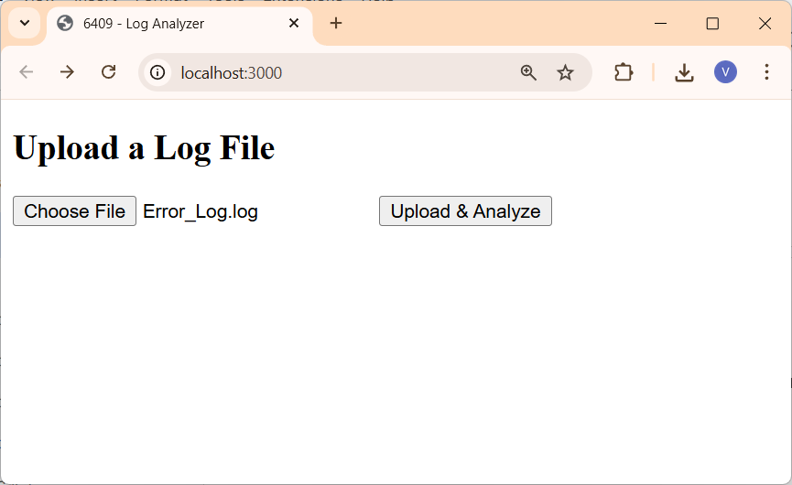

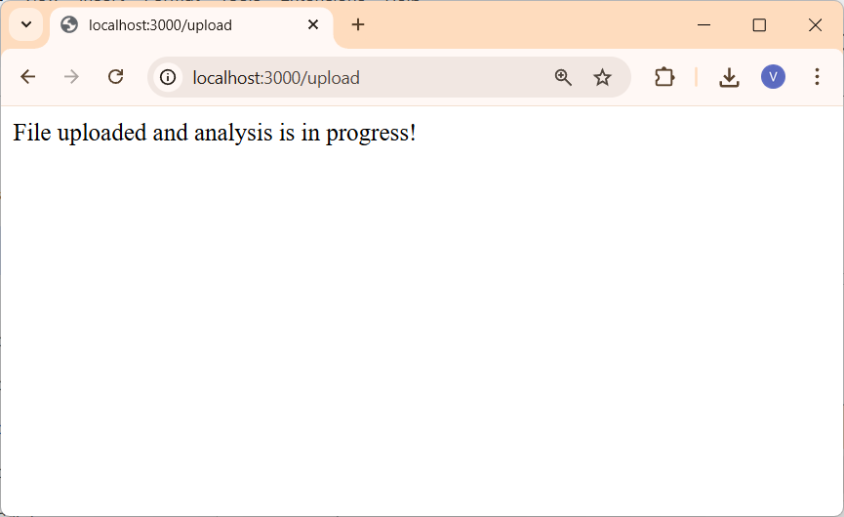

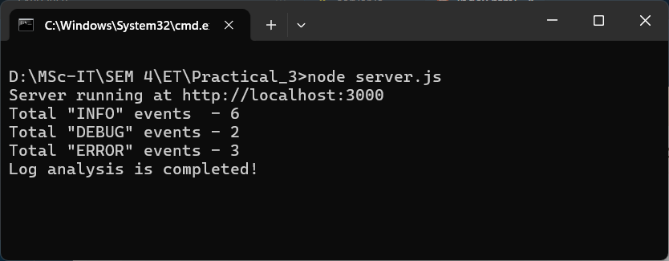

log file uploaded
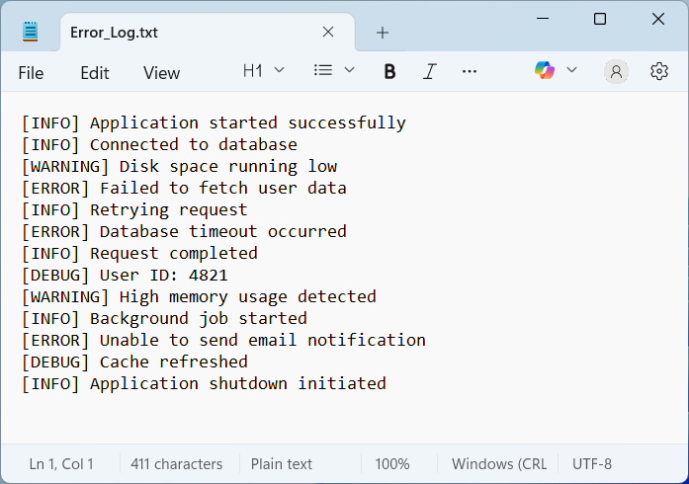

Create a React application that uses Redux Toolkit for state management. The application should maintain a list of cricketers in the Redux store and allow the user to filter the list by typing a name in a search box.

- Create React app - redux_prac and install required redux toolkit by using following cmd

D:\MSc-IT\SEM 4\ET\practical_9>npx create-react-app redux_prac
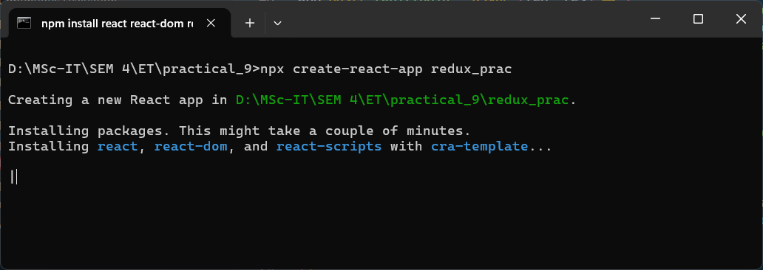

D:\MSc-IT\SEM 4\ET\practical_9>cd redux_prac
D:\MSc-IT\SEM 4\ET\practical_9\redux_prac>npm install @reduxjs/toolkit react-redux
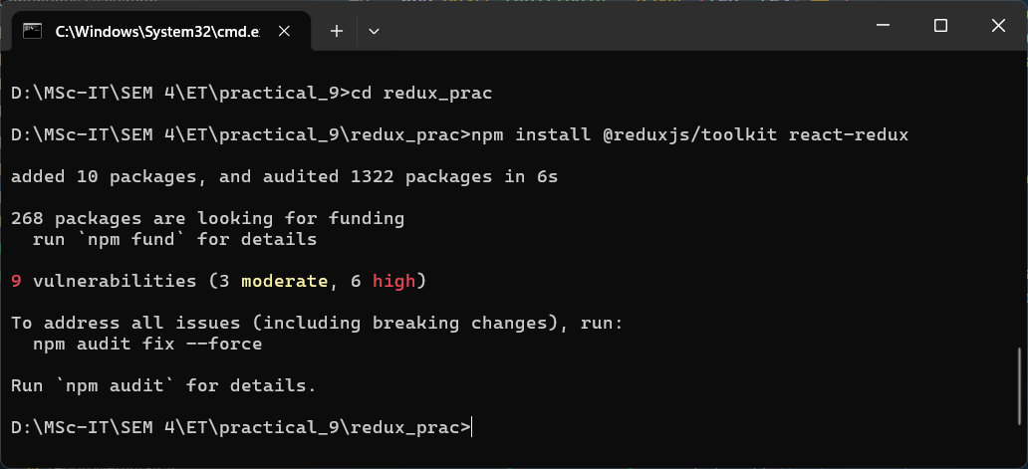

Create project and directory structure like below
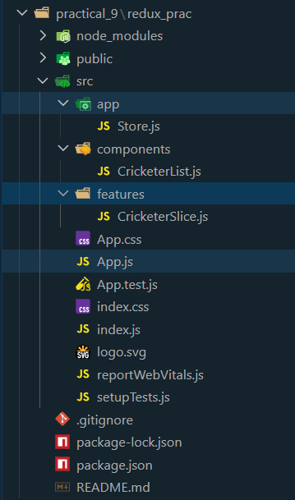

CricketerList.js

import React from "react";
import { useSelector, useDispatch } from "react-redux";
import { setSearchTerm } from "../features/CricketerSlice";
const CricketerList = () => {
const dispatch = useDispatch();
const { list, searchTerm } = useSelector((state) => state.cricketers);

const filteredList = list.filter((name) =>
name.toLowerCase().includes(searchTerm.toLowerCase())
);

return (
<div>
<h2>Cricketer Search</h2>

<input
type="text"
placeholder="Search cricketer..."
value={searchTerm}
onChange={(e) => dispatch(setSearchTerm(e.target.value))}
/>

<ul>
{filteredList.map((name, index) => (
<li key={index}>{name}</li>
))}
</ul>
</div>
);
};

export default CricketerList;

CricketerSlice.js

import { createSlice } from "@reduxjs/toolkit";

const initialState = {
list: [
"Virat Kohli",
"MS Dhoni",
"Jasprit Bumrah",
"Rohit Sharma",
"Hardik Pandya",
"Shikhar Dhawan",
"Yuzvendra Chahal",
"Ravindra Jadeja",
"KL Rahul",
"Bhuvneshwar Kumar",
],
searchTerm: "",
};

const cricketersSlice = createSlice({
name: "cricketers",
initialState,
reducers: {
setSearchTerm: (state, action) => {
state.searchTerm = action.payload;
},
},
});

export const { setSearchTerm } = cricketersSlice.actions;
export default cricketersSlice.reducer;

store.js

import { configureStore } from "@reduxjs/toolkit";
import cricketersReducer from "../features/CricketerSlice";

export const store = configureStore({
reducer: {
cricketers: cricketersReducer,
},
});

export default store;

App.js

import React from "react";
import CricketerList from "./components/CricketerList";

function App() {
return (
<div style={{ padding: "20px" }}>
<CricketerList />
</div>
);
}

export default App;

index.js

import React from "react";
import ReactDOM from "react-dom/client";
import { Provider } from "react-redux";
import App from "./App";
import store from "./app/store";

const root = ReactDOM.createRoot(document.getElementById("root"));
root.render(
<Provider store={store}>
<App />
</Provider>
);

Output

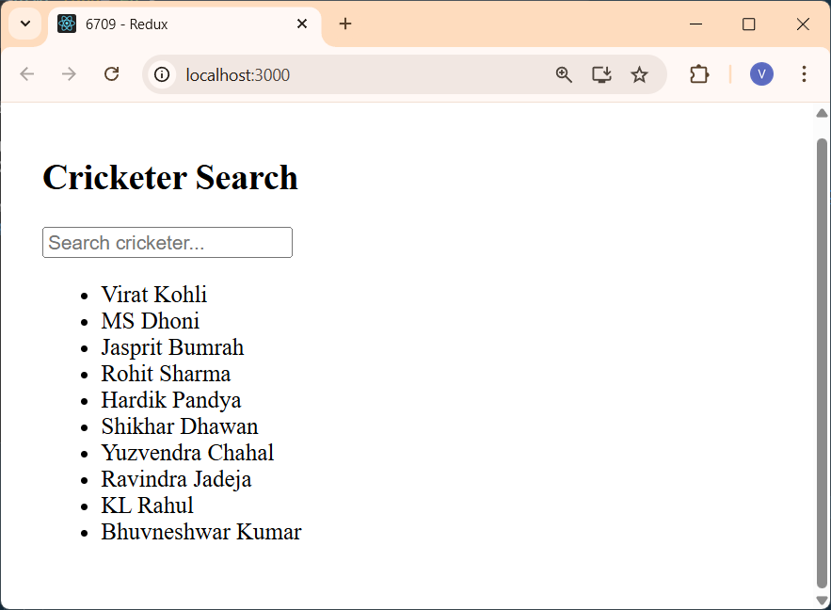

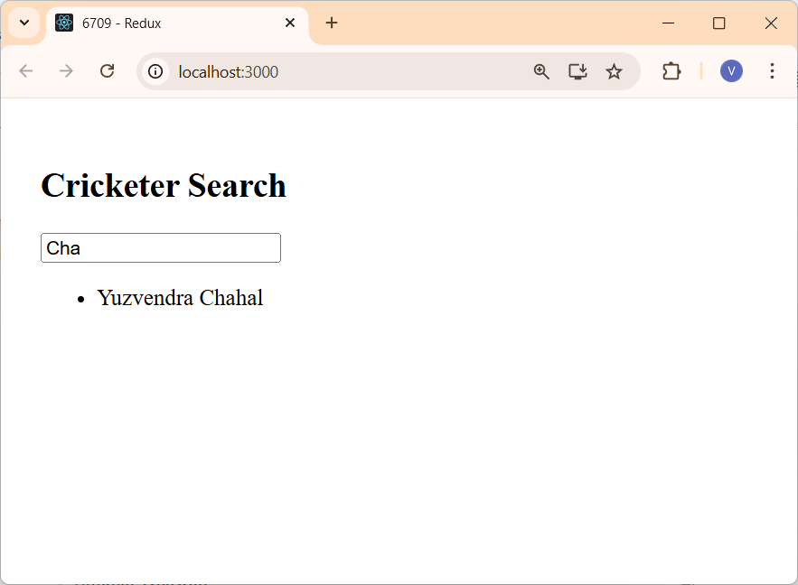

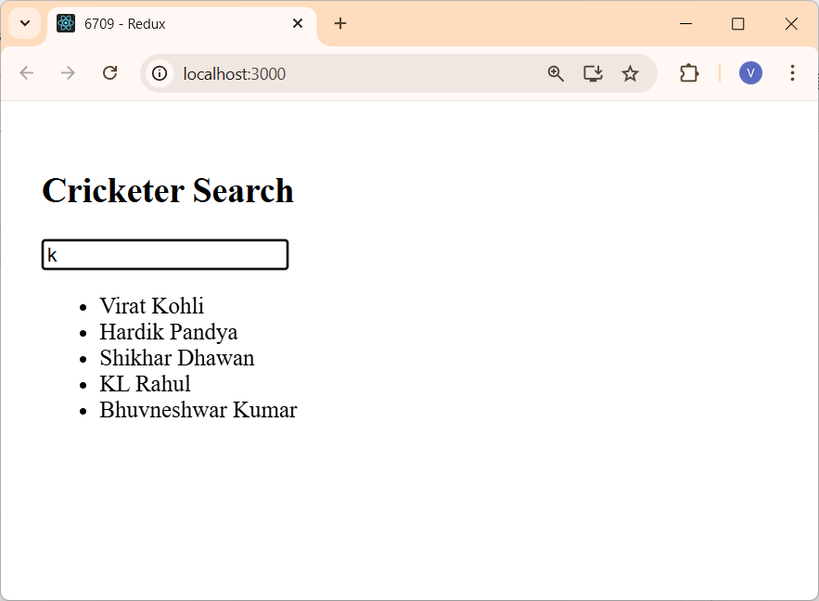

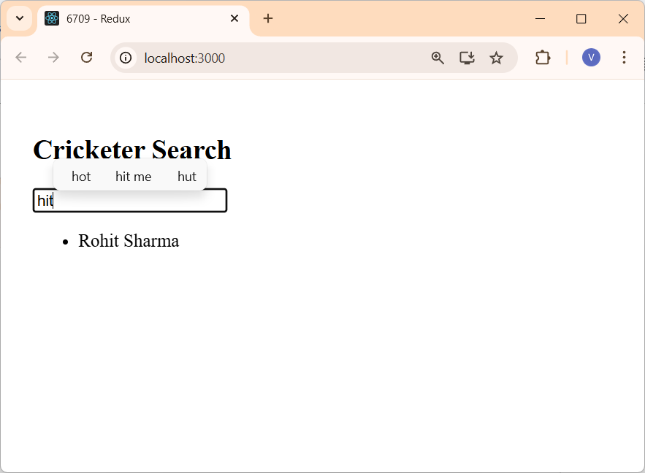

Create a React application and implement a simple React component that displays a text message like HELLO WORLD. Write a test case to verify that the component renders the expected text using React Testing Library and Jest Test Runner.

D:\MSc-IT\SEM 4\ET\Continuous Evaluation>npx create-react-app testing-app

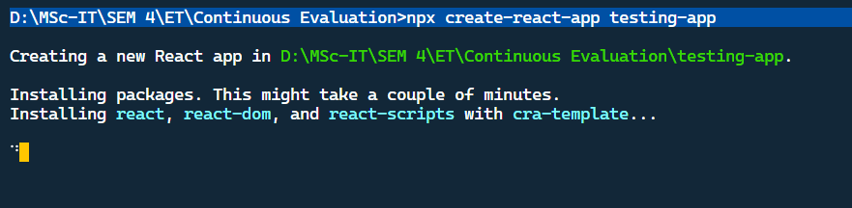

D:\MSc-IT\SEM 4\ET\Continuous Evaluation\testing-app>npm install --save @testing-library/react @testing-library/jest-dom

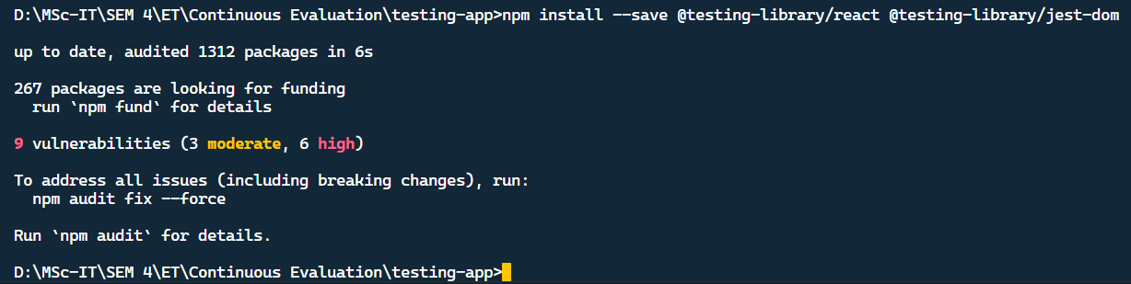

create new file called, HelloWorld.js

import React from 'react'

function HelloWorld() {
return (
<div>
<h1>Hello, I am Shivam Vishwakarma.</h1>
<h2>From MSCIT part 2, Sem 4</h2>
</div>
)
}

export default HelloWorld
create test file called HelloWorld.test.js

import React from 'react';
import { render, screen } from '@testing-library/react';
import '@testing-library/jest-dom';
import HelloWorld from './HelloWorld';

test('renders the heading', () => {
render(<HelloWorld />);
const element = screen.getByText(/hello/i);
expect(element).toBeInTheDocument();
});

test('renders the subheading text', () => {
render(<HelloWorld />)

const subHeading = screen.getByText('From MSCIT part 2, Sem 4')
expect(subHeading).toBeInTheDocument()
})

test('uses correct heading levels', () => {
render(<HelloWorld />)

const h1 = screen.getByRole('heading', { level: 1 })
const h2 = screen.getByRole('heading', { level: 2 })

expect(h1).toHaveTextContent('Hello, I am Shivam Vishwakarma.')
expect(h2).toHaveTextContent('From MSCIT part 2, Sem 4')
})

run npm test command

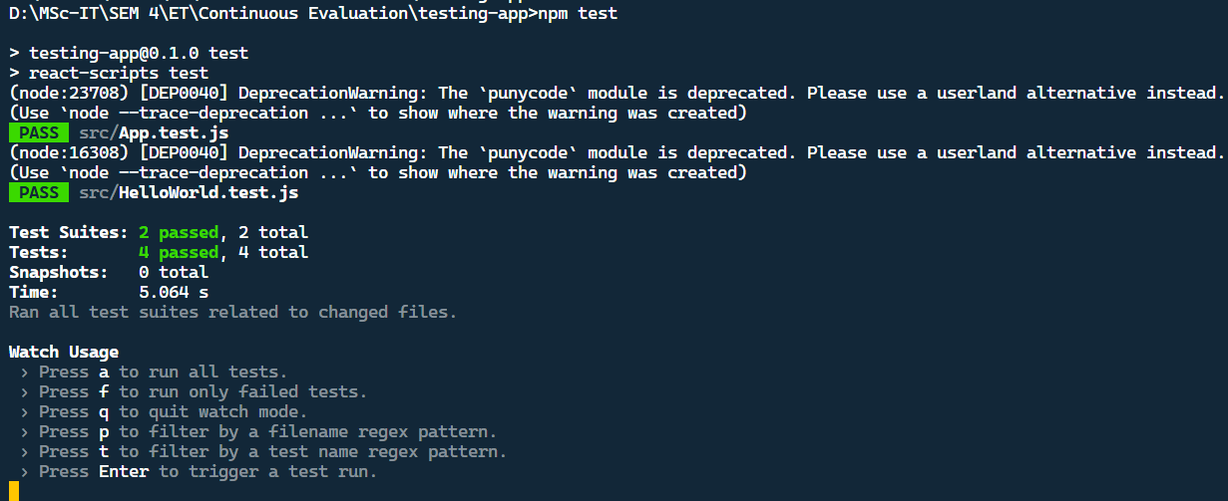

Using Parent/Child Components in React to create an application.

D:\MSc-IT\SEM 4\ET\Continuous Evaluation\testing-app>create-react-app@latest contextapi

Context.js

import { createContext } from "react";

export const SubjectContext = createContext("Maths")

Class.js

import Student from "./Student";

export default function ClassComponent() {
return (
<div style={{ backgroundColor: 'skyblue', padding: 10 }}>
<h1>ClassComponent Component</h1>
<Student />
</div>
);
}

Student.js

import Subject from "./Subject";

export default function Student() {
return (
<div style={{backgroundColor:'green', padding:10}}>
<h1>Student Component</h1>
<Subject />
</div>
);
}

Subject.js

import { useContext } from "react";
import { SubjectContext } from "./Context";

export default function Subject() {
const subject=useContext(SubjectContext)
return (
<div style={{backgroundColor:'red', padding:10}}>
<h1>Subject is: {subject}</h1>
</div>
);
}

College.js

import ClassComponent from "./Class";

export default function College() {
return (
<div style={{ backgroundColor: 'orange', padding: 10 }}>
<h1>College Component</h1>
<ClassComponent />
</div>
);
}

App.js

import './App.css';
import College from './College';
import { SubjectContext } from './Context';
import { useState } from "react";

function App() {
const [subject, setSubject] = useState('ET');
return (
<div style={{ backgroundColor: 'yellow', padding: 10 }} >
<SubjectContext.Provider value={subject}>
<select onChange={(event) => setSubject(event.target.value)}>

<option value="">Select Subject</option>

<option value="ET">ET</option>
<option value="AIOT">AIOT</option>
<option value="CF">CF</option>
<option value="RP">RP</option>

</select>

<h1>Context API Practical</h1>
<button onClick={() => setSubject('')}>Clear Button</button>

<College />
</SubjectContext.Provider>

</div>
);
}

export default App;

Output

